

**MARMARA UNIVERSITY COMPUTER ENGINEERING**

**CSE 1142**

**COMPUTER PROGRAMMING II**

**Spring 2018**

**Date Submitted: May 20, 2018**

**TERM PROJECT**

**Taha Yusuf KÖMÜR Furkan Can ERCAN**

**150114064 150316044**

**Problem Definition**

Our problem was a game design problem.First of all we tried to understand and analyze this game.We thought the game as some kind of puzzle. It contains circles, half circles, lines. To solve the puzzle, it is necessary to disappear the lines and half circles in the correct order. We used circles to disappear them. When we clicked on the circles, the line to which it is connected and the elementary circle on it should be shifted. If there was no collision during the belt, it should disappeared successfully. If the player clicks on all the circles in the correct order, he should gone to the next level.On the other hand if there was a collision we should have animated it and all object should have disappeared.With this analysis and perspective we tried to solve the problem.

**Implementation Details**

After the understanding and analysis part,we divided the project to classes.We designed every level as a different class and also a class for menu.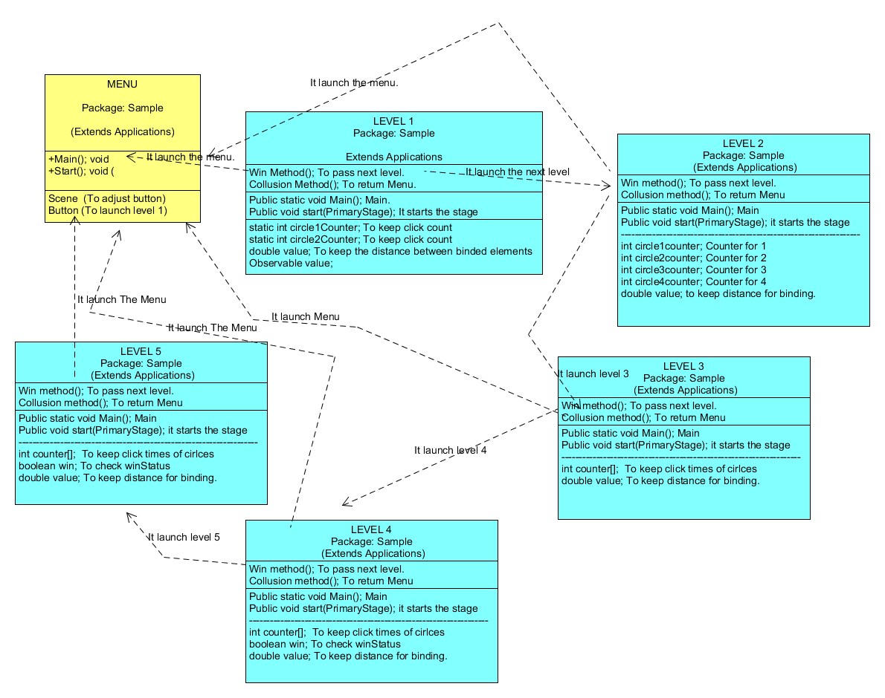

Every level has its own methods to determine whether user passed level or not.Additionally all these levels has tons of rectangles circles arc etc. but because of the amount is too large we did not show them in uml diagram.The uml diagram demonstrates a general portrait about all classes.

After this general design we first tried to develop levels individually and helped each other time to time to solve the problems we encountered.The levels has tons of animations and shapes.We first created only the gui parts.Then ordered our codes to read it easily.Then slowly added the slide and disappear animations.

First problem we encountered was that how to disappear the objects.We solved it with hiding the shapes to rectangles which has the same colour with background so that they are invisible.

Secondly it was too hard to animate all the objects individually and it was really hard to make them synchronized.So we researched the binding concept and applied it to our code.

Thirdly to disappear the all elements to do that we had 2 different ways.One of us used our hiding technique in a different way and one of us wrote different methods and arrays to put all shapes together and animate them with a method in for loops.

After we completed the levels individually we had to make them work together.The game should started with level1 and it should progressed to other level.

First we had an exception which is java.lang.IllegalStateException: Cannot set style once stage has been set visible.We solved it with deleting the transparent code in levels and writing this code in to menu class.Our problem solved and our windows looked transparent as we wanted.Then we tried to make the progression.If user pass the level it should progressed to next level.We first tried to control it in menu class with calling isWin methods of levels in that class but it did not worked and we could not solve this problem.So we tried a different thing we controlled it in levels and in every level after controlling the winning condition we created an object of next level.After that we encountered another problem our game was progressing but it was skipping the last animations because java was not a single pass language it was doing all the thing s at same time and we needed to delay the progression part.We made researches about it and with using different methods which we found on internet we delayed the progression part.

At the end we think that we solved nearly every problem we had and we made every necessary parts of the game we do not have any missing part.Differently from project if a user fails a level we did not restart the corresponding level again we made user back to the main menu.We thought that it was more challenging and decided to do it as in this way.

**Test Cases**

In test cases we tried to explain and demonstrate all sitiuations for each level with the help of screenshots.In this section all of our effort can be seen.

At the initial step of the program a simple and plain menü design welcomes the user.With the help of play button the game can be started.

After pressing play button first level of the game appears.

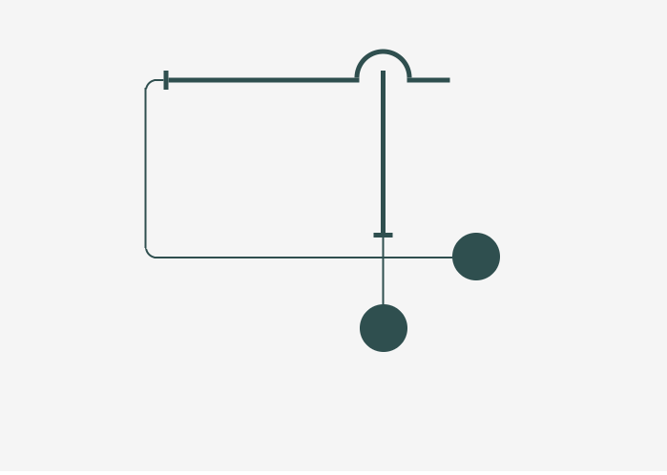

Level 1 is not a complicated level.There is only one possibility for collision case.If user firstly press the circle at the bottom there is no collision occurs the rectangle stick disappears with an animation and rest of parts fade out.

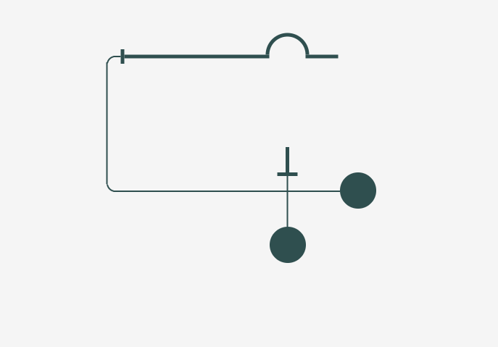

Rectangle stick disappears with animation



Fade out of first parts



After first parts completed and faded out the game looks like this.The user should press the remaining circle and win the game.With pressing circle first rectangle stick slides to left with animation and remainig parts fade out then level1 windows closes and level2 which is the next level opens.



There is one more sitiuation in level1 which is collision.If user press the circles in a wrong order collision occurs and all fade out then it returns the main menu.

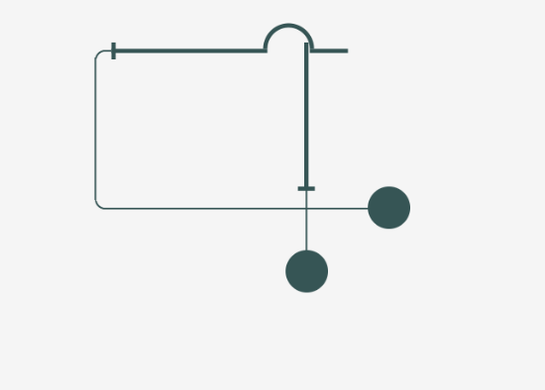

Collision occurs.

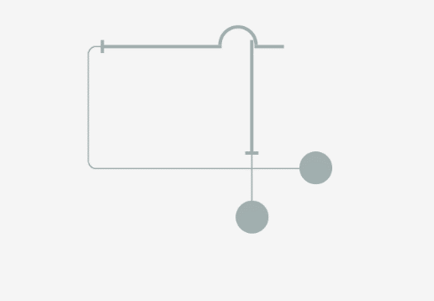

All parts fade out.

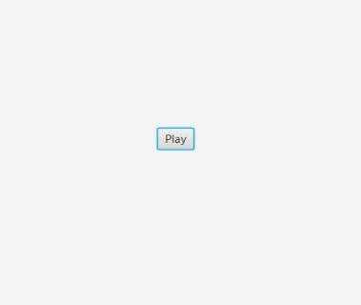

The game returns the main menu.

If the user can win the first level game continues to next level as mentioned above.

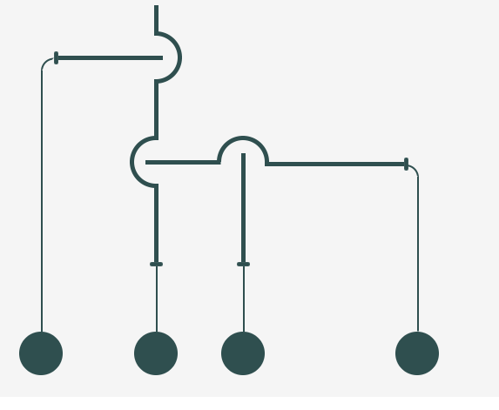

Level 2 is a more complicated level but has the same logic with level1.So to make clarification easier let the circles be circle1,circle2,circle3 and circle4 from left to right respectively.

There are 2 winning patterns in this level.It changes according to first pressed circle it can be circle1 or circle3.There are collision cases and no collision cases and one of the no collision case is also winning case.At collision case after the animation and fade out the game returns the main menu in winnig case game continues to the next level.

Collision Cases:

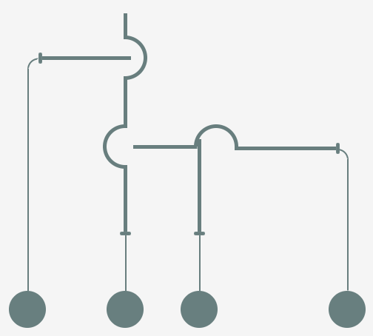

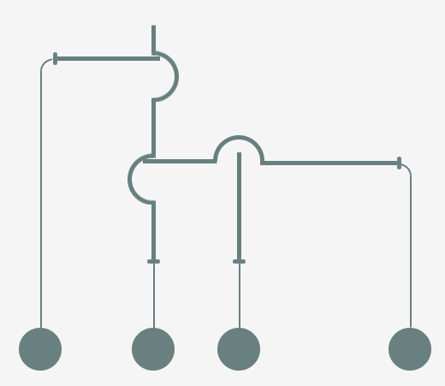

No Collision Cases:

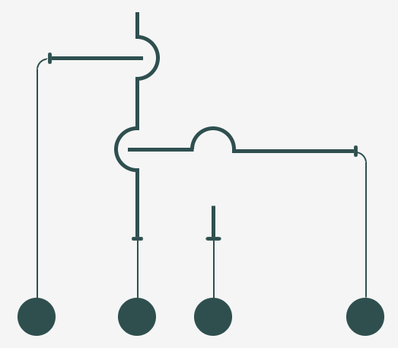

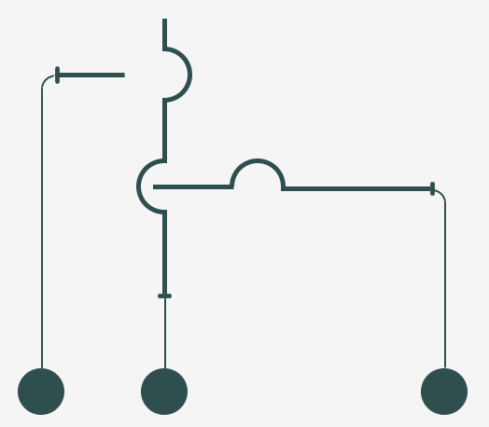

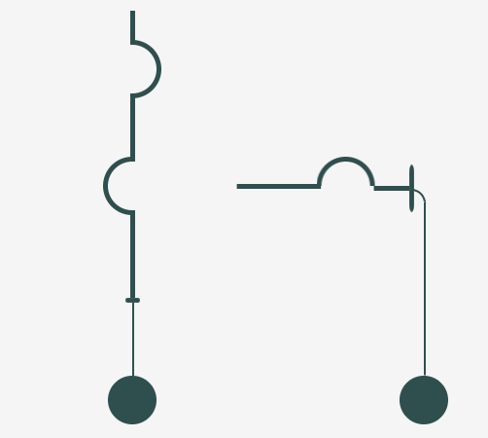



After the last no collision case the game continues to next level which is level3.

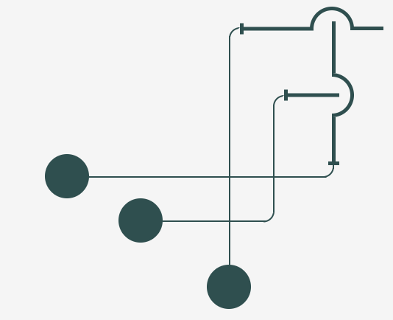

Level3 is also not a very complicated part of the game.There is a single pattern to win the level.

To make clarification easier let the circles be circle1 circle2 and circle 3 from top to bottom respectively.The user should press to circle 2 first then circle 1 and at the last circle1 to win the level.There are 2 collision cases which may occur and 3 no collision cases for 3 circles.

Collision Cases:

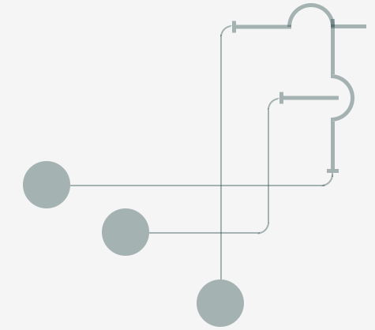

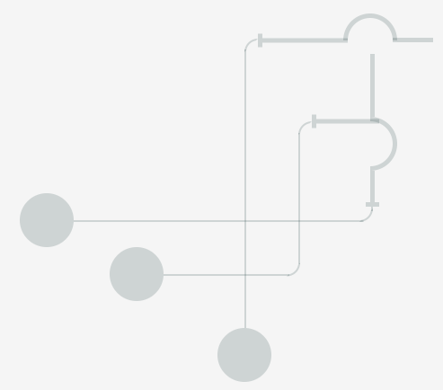

No Collision Cases:

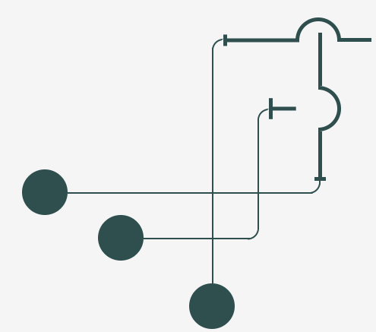

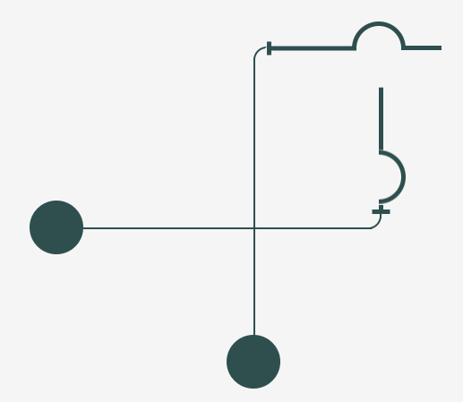



After the last no collision case the game continues to next level which is level4.

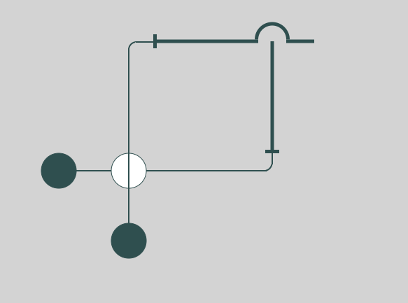

This level is actually simple level with a new feature.The rectangle in White circle should be vertical or horizontal according to circle pressed.The level has 1 collision case and 2 no collision cases.If the rectangle in White circle is not setted accurately the animation does not occur.As mentioned before after collision case game returns the main menu and if user win the level game continues to the next level.

Collision Case:

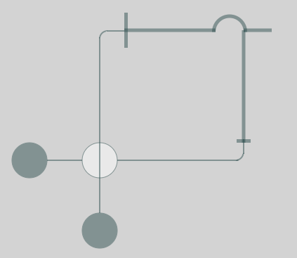

No Collision Cases:

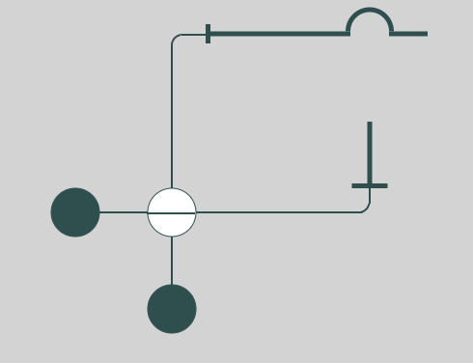

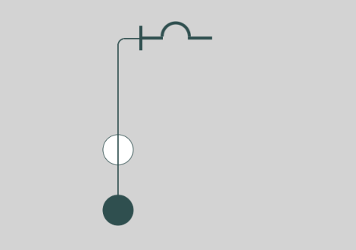

After the last no collision case the game continues to next level which is last level level 5.

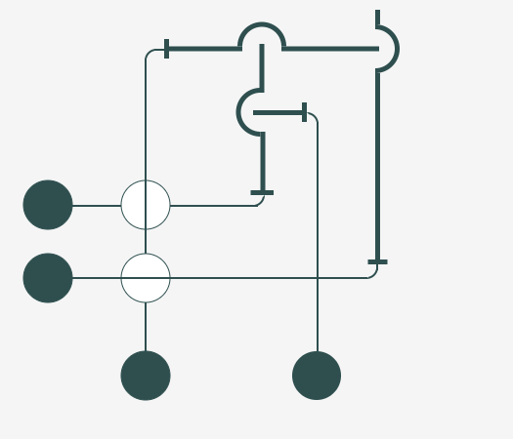

Level 5 is the last level of the game and due to that it can be said that it is the most complicated level of all.There are 4 dark-coloured circles and 2 white circles.The rectangles at circles controls the animations similar to the level 4.There are 4 no collision 3 collision cases.In collision cases the game returns the main menu.In winnig pattern game ends with a message and congratulate the user.

Collision Cases:

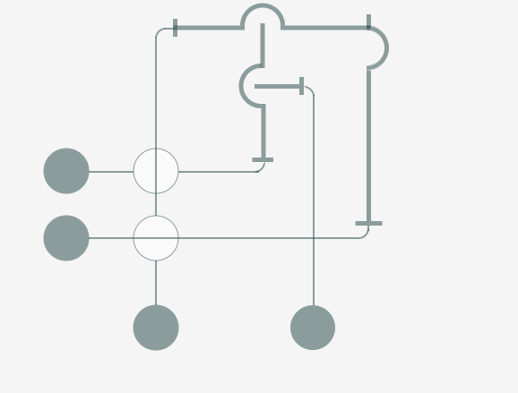

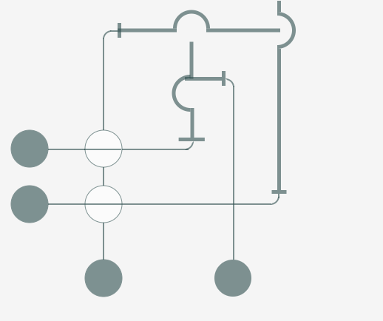

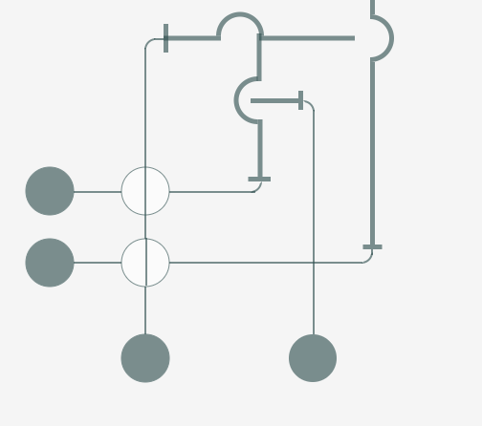

No Collision Cases:

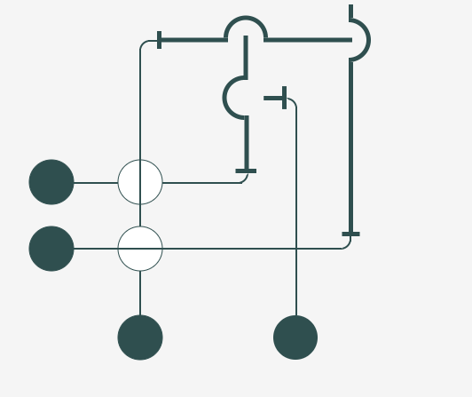

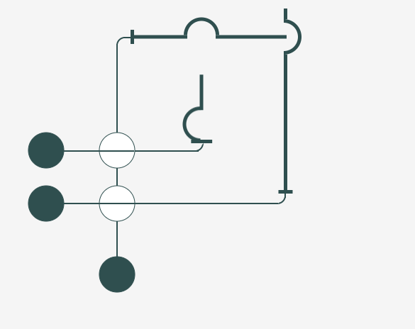

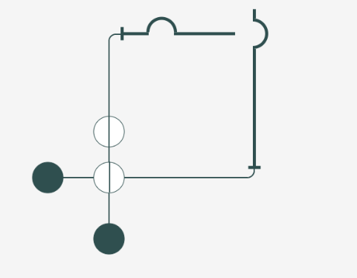

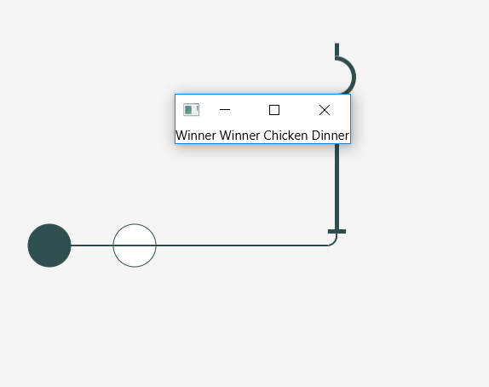



After winning message game is over.